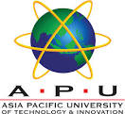

**GROUP ASSIGNMENT**

**TECHNOLOGY PARK MALAYSIA**

**ERA002-3-1**

**Intercultural Awareness and Cultural Diversity**

**NP1F2309IT**

**HAND OUT DATE: 11 June 2024**

**HAND IN DATE: 27 June 2024**

**WEIGHTAGE: 100%**